
Human Biology – General Year 12 Task 3 – Unit 3
Name: _________________________________
Assessment type: Test
Conditions: -------------/49 = ----------------------
Period allowed for completion of the task: Wednesday 13th of March
Task weighting: 9% of the school mark for Units 3 and 4
Task 3: Test- Muscular and skeletal systems (49 marks)
Multiple Choice (10 marks)
- How many bones does an adult skeleton have?
  - 206
  - 207
  - 205
  - 309

- A vertebrate is
  - A plant with a skeleton
  - An animal with an internal skeleton
  - An animal with an external skeleton
  - An animal without a skeleton

- The skeletal system has two distinctive parts. They are:
  - The spinal cord and rib cage
  - The axial skeleton and appendicular skeleton
  - The spinal cord and appendicular skeleton
  - The spinal cord and axial skeleton

- Early in the development of a human foetus, the skeleton is made almost entirely of
  - Bone
  - Callused bone
  - Rubber
  - Cartilage

- What is a joint?
  - Bones that absorb calcium at high levels
  - The site at which two or more bones come together
  - Bones that have muscles attached to them
  - Bones that are remodelling due to a fracture

- What type of fracture is common in children?
  - Closed fracture
  - Open fracture
  - Greenstick fracture
  - Avulsion fracture

- What is a hairline fracture?
  - When two bones are forced against each other
  - When the broken bone juts out through the skin
  - A small slender crack in the bone
  - A stress fracture from repeated activities such as running

- What is included in the musculoskeletal system?
  - Joints, bones and skeletal muscles
  - Bones only
  - Bones and muscles
  - The cardiac and skeletal systems

- What are the three types of muscles?
  - Skeletal, axial and smooth
  - Skeletal, smooth and cardiac
  - Cardiac, smooth and appendicular
  - Cardiac, smooth and joints

- Muscles can only
  - Contract
  - Contort
  - Extends
  - Concave

Short Answer (23 marks)
- Briefly describe the process of bone remodelling (3 marks)
_______________________________________________________________________________________________________________________________________________________________________________________________________________________________________________________________________________________________________________________________________________________________________________________
- Explain how movement occurs for each of the following terms (10 marks)
- Flexion
____________________________________________________________________________________________________________________________________________________________________________________________________________________________________________________________________________________
- Extension
____________________________________________________________________________________________________________________________________________________________________________________________________________________________________________________________________________________
- Abduction
____________________________________________________________________________________________________________________________________________________________________________________________________________________________________________________________________________________
- Adduction
____________________________________________________________________________________________________________________________________________________________________________________________________________________________________________________________________________________
- Rotation
____________________________________________________________________________________________________________________________________________________________________________________________________________________________________________________________________________________

- Broken bones or bone fractures occur when a force is exerted against a bone that is stronger than the bone can handle
- Describe first aid that can be offered directly after the bone has fractured
(3 marks)
_________________________________________________________________________________________________________________________________________________________________________________________________________________________________________________________________________________________________________________________________________________________
- The process of healing for the bone that is fractured (3 marks)
_________________________________________________________________________________________________________________________________________________________________________________________________________________________________________________________________________________________________________________________________________________________
- Label the diagram to show a (4 marks)
  - Fixed or fibrous joint
  - Hinge Joint
  - Pivot Joint
  - Ball and Socket Joint
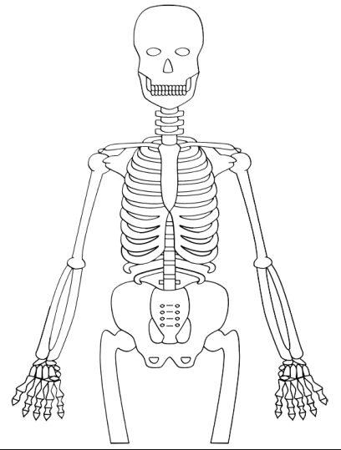

Extended Answer (16 marks)
- Fill in the table (16 marks)
Type of Joint | Definition and description. | Example or diagram
Fixed or fibrous joint
Slightly movable or cartilaginous joint
Freely movable or synovial joint
Ball and socket joints
Hinge Joints
Pivot Joints
Gliding Joints
Saddle Joints

